以筆跡偵測字母輸入

黃秉茂

王祥任

李昀奇

國立交通大學資訊學院資訊工程學系

Department of Computer Science

National Chiao-Tung University

中華民國 110 年 12 月

December, 2020

**Abstract**

希望透過筆順、位移、轉角角度物理數據等判別字母。

**Motivation**

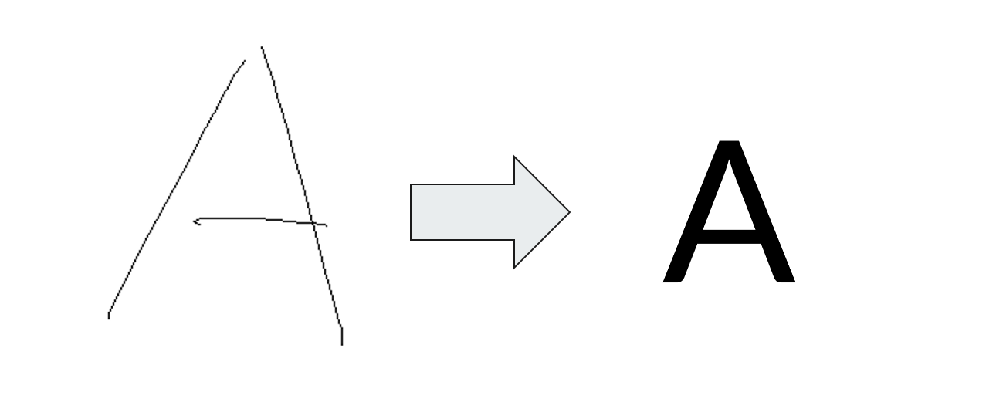

**Data**

**Data Collection**

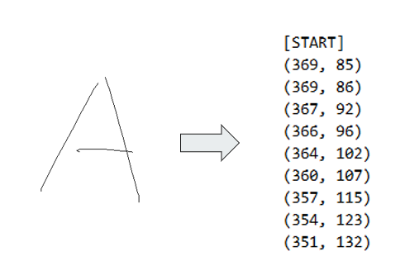**Tool**

* 自己寫的小畫家
* 紀錄路徑
* 大寫英文字母

**Data**

* About 760 records
* Each letter has about 25 records.

**Statistics**

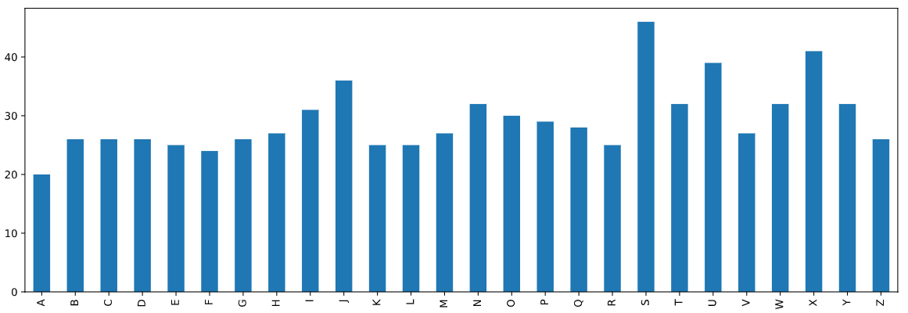

**Data Preprocessing**

**Problem — Number of Dimension**

* The number of samples of each stroke is different.
* The number of strokes of each letter is different.

**Features of each letter**

* The upper bound of the number of strokes of each letter is 4.
* Zero-padding for those # of strokes is lower than 4.
* [Letter][Stroke#1][Stroke#2][Stroke#3][Stroke#4]

**Features of each stroke**

* + - * 角度
      * 位移長度
      * 路徑長度
      * 路徑長相較位移長之倍率
      * 該筆劃之起點相較第一筆劃起點之距離
      * 斜率於X軸上變號之次數
      * 斜率於Y軸上變號之次數

**Stroke**

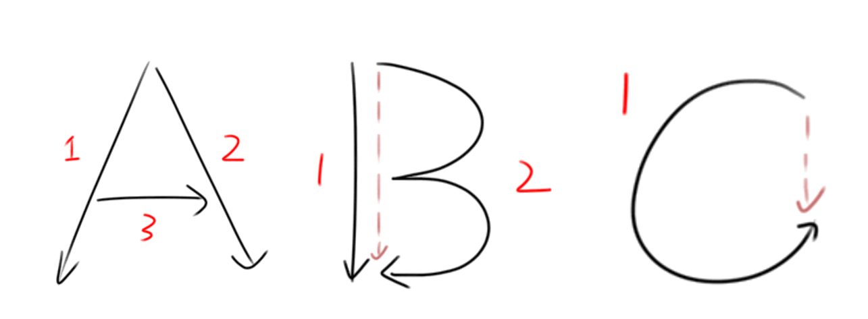

* + - * One-stroke letter is hard to identify by feature 1 to 5.
      * Feature 6 and feature 7 to identify the change of slope.



**Enhancement**

Angle is the most important feature, so sign-square itself to enhance it.

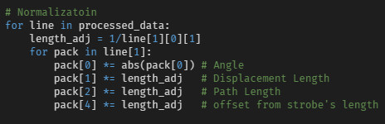

**Normalization**

The size of bounding box of each record may be different.



**Results**

**Data Preprocessing**

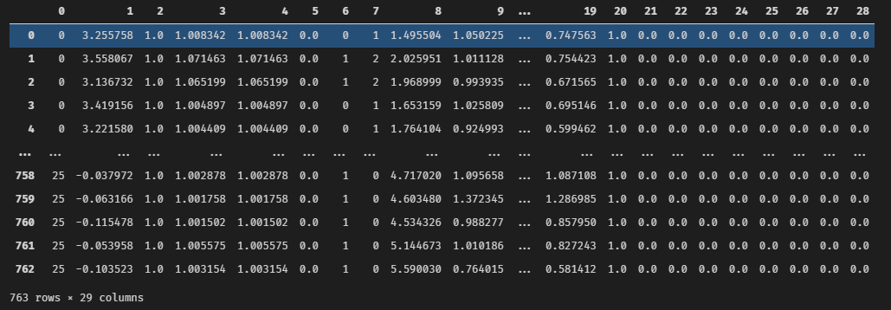

**Model – KNN**

* **Accuracy : 0.96**
* 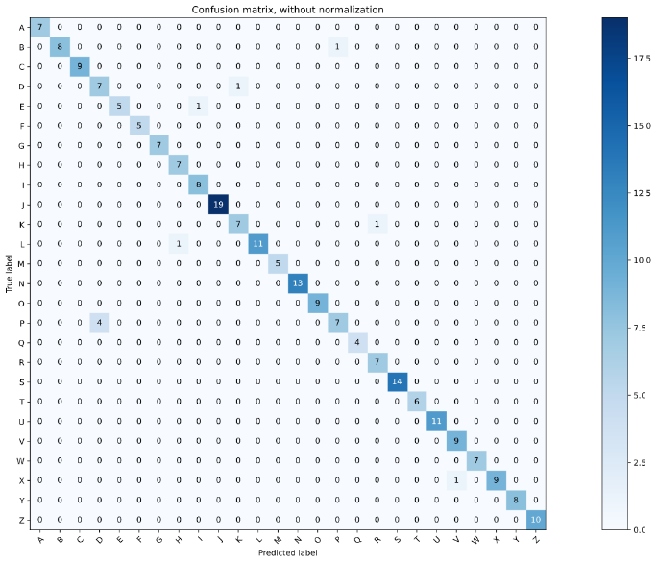**B-P**
* **D-K**
* **E-I**
* **P-D**
* **K-R**

**Model - Random Forest**

* **Accuracy : 1.00**
* 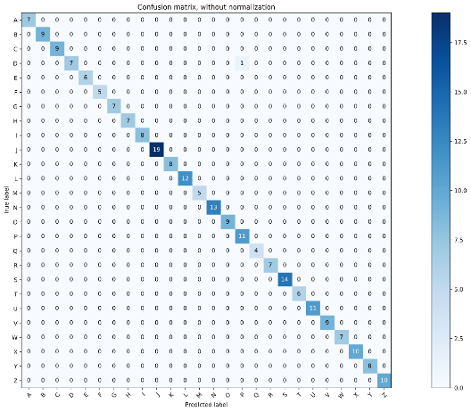**D-P**

**Model – SVM**

* 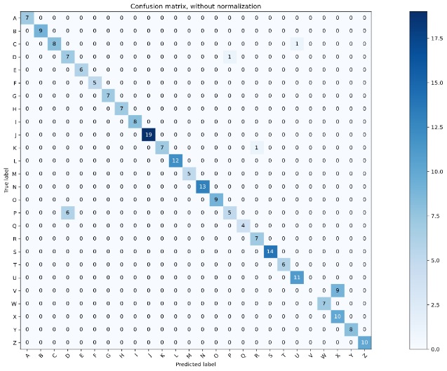**Accuracy : 0.92**
* **D-P**
* **K-R**
* **C-U**
* **V-X**

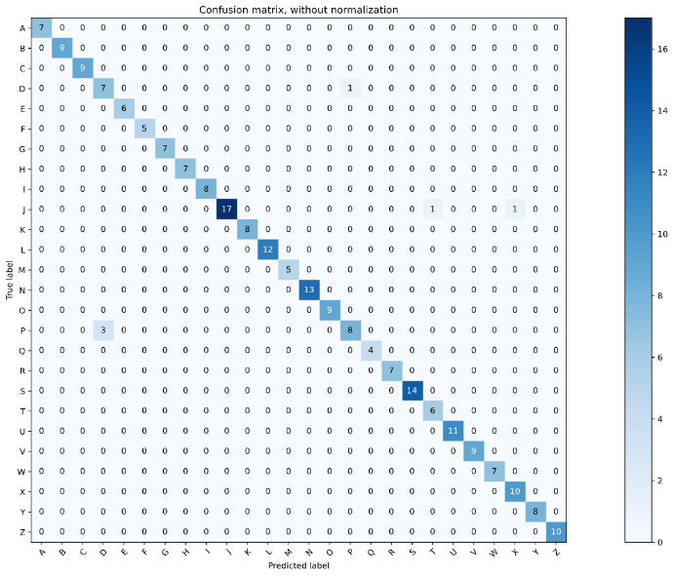**Mondel – ANN**

* **Accuracy : 0.97**
* **D-P**
* **J-T**
* **J-X**

**Conclusion**

* **Only need 28 features for each data**
* **Accuracy is high**
* **D-P is hard to identify**
* **Not very general**
* **Highly depends on user**